Women’s Softball League
Playing Conditions

- Aim
To create a competitive, but friendly women’s softball cricket league.
- Pitch
  - Two sets of wickets, 19 yards apart (can be flexible based on the size of the home outfield)
  - Boundaries are ideally of 40 – 50 yards
- Teams
  - Each team comprises of 8 players.

- The Start
  - The two teams toss a coin to decide which team has the choice of either batting or fielding first.
  - Teams should use the bats that were supplied with the Women’s Softball Cricket Kits
  - Teams should try to complete a team sheet of players before the game.

- The Ball
  - The ball should be a senior size incrediball
  - The balls should be supplied by the host.

- The Game
  - Throughout the league each game shall consist of one innings per team
  - An innings can be 12 overs (3 over per batting pair) or 16 overs (4 overs per batting pair)
- Batting & Scoring
  - The batting side shall be divided into pairs. Pairs and order are arranged by the team/captain.
  - Each team starts batting with a score of 0 runs.
  - Each time a batter is out, 5 runs are added to the bowling teams batting total and the other batter of the pair faces the next ball.
  - A batter may be out bowled, caught, run out, stumped, hits wicket.
  - There is no LBW law unless the batter deliberately blocks the ball with a leg or foot.
  - Runs will be scored in the normal way, as will byes.
  - 2 runs will be awarded to the batting team for each wide ball and no-ball bowled, but no extra ball will be allocated, except in the final over when the award for a wide is 1 and the ball is re-bowled.
  - At the end of the first pair, batters retire and are replaced by the next pair, until all players have batted.
  - The second team then bats for an equal amount of overs.
  - If a team has less than the full complement of 8 players, then the person(s) who scored the lowest runs, shall bat again to ensure pairs bat.
- Bowling and Fielding
  - Each player can bowl a maximum of 3 overs(12 over innings) or 4 overs (16 over innings).
  - Bowling will take place from one end only.
  - Bowling should be over arm where possible. Umpires will encourage bowlers to ball overarm, unless it is to the detriment of the batter. Under arm bowling will be accepted, if the bowler really struggles to bowl over arm, but the batter cannot be out bowled or caught.

  - Players on the fielding side DO NOT need to rotate fielding positions.
  - With the exception of the wicketkeeper no fielder may field within 10 yards of the wicket, measured from the middle stump except behind the wicket on the off-side. A fielder may move into the restricted area to field a ball provided he/she was outside the area when the stroke was made.

- The Result
  - The team with the higher score wins.
  - The results should be ideally uploaded to Play Cricket within a week of the fixture. If this is not possible, then the score sheets should be sent electronically to Ann-Marie Presswell, Women and Girl’s Development Officer.

- Umpires
  - Each team is to provide one umpire.
  - Two umpires per pitch (one form each team).The square leg is there to advise on run outs and no balls. Ideally the umpires should have equal amounts of time as the bowlers end umpire.

- Scoring
  - Each team will be responsible for providing a scorer. The scorer from both teams MUST sit together.

  - Scorers can use the play cricket app where the fixtures will be loaded, or they can score manually on the agreed score sheet.

- Age
  - Women’s softball cricket is a game designed for women, but it is recognised that younger girls may wish to play. A junior may play, but has to be at least 13 years of age, or school year 8 and have experience of playing cricket. It will be down to clubs to have duty of care to ensure that players participate at a level commensurate with their age, ability, maturity, interest and mental/psychological understanding.

- County Players
  - Whilst the league is still very new with many women playing for the first time, we ask that each team plays within the spirit of cricket. Therefore, county players or county pathway players are not able to play in the Softball League as it is not the environment for them.
  - As players are new and playing cricket for the very first time, this tournament is also not for those ladies/players who are regularly part of the established hardball cricket team.

- Borrowing/Loaning of Player
  - Teams can only borrow a maximum of 2 players per fixture

  - If, a team needs more than 2 players in order to get the game played, then they forfeit the match and the other team will get the points.

- Spirit of Cricket

  - Cricket is a game that owes much of its unique appeal to the fact that it should be played not only within its Laws, but also within the Spirit of the Game. Any action which is seen to abuse this spirit causes injury to the game itself. The major responsibility for ensuring the spirit of fair play rests with the captains.

  - The women’s softball League is designed to engage players. Whilst it is a league, we ask that Captains do their up most to ensure games are event contested and as such keep players and teams wanting to play more!

  - Team captains will be issued the SCB Code of Conduct, of which teams will be expected to adhere too.

  - Team captains are to discuss and resolve on the day, any issue that are brought to their attention. If either team feels that the issue cannot be resolved, then please contact Ann-Marie Presswell, Women and Girls Development Officer.

  - There will be an end of season Fair Play award- each club will nominate a team.

Glossary

- An Over
10.1 An over consists of 6 balls.
- LBW
  - In the very simple terms, a batter can be given out if the umpire feels that a ball, which hits the batter’s leg, would have hit the stumps. This law will not be used unless a batter deliberately blocks or kicks the ball away with the leg or foot.

- Byes
  - If a batter misses the ball, or if it hits their body, they may still run and score byes.

- Wide ball
  - A ball that is too far from the batter to strike will be called a wide. A ball will not be called a wide, no matter how wayward it may be, if the batter manages to hit it.
  - Wides are scored as two additional runs to the batting team and not re-bowled unless it is the final over.
  - In the final over, wides only score 1 additional run to the batting the team.

  - If the batters choose to run on a wide, these runs shall also be added to the total as wides.

- No ball
  - If a ball bounces more than twice before reaching the batsman, or if it reaches the batsman above hip/pocket height without bouncing, it will be called a no ball.

  - If a bowling underarm, the ball must bounce once, but not more than twice before reaching the batter.

  - A batsman may hit a no ball and any additional runs made form the ball will be added to the score.

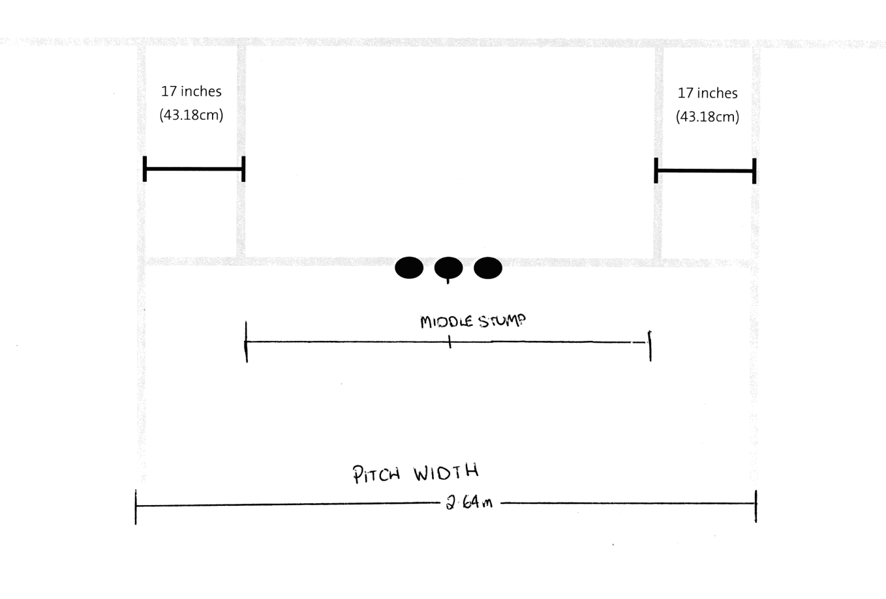
  - No Balls are scored as two additional runs to the batting team and not re-bowled unless it is the final over.
  - In the final over, No Balls only score 1 additional run to the batting the team.

