Women’s Softball League
Playing Conditions 2024

- Aim
The aim of the Devon Women’s Softball league is to create a standalone competitive playing platform to increase participation and women’s enjoyment in cricket.

- Pitch
  - Two sets of wickets, 19 yards apart
  - Boundaries are 40 – 50 yards
  - Wide lines will be marked on the wicket. These should

- Season and Finals
3.1 Games should be played between the May Bank Holiday weekend and the August Bank holiday weekend.
3.2 All fixtures should be arranged and updated on Play Cricket by 1st February
3.3 Semi-Finals and Finals will be organised and coordinated by the Devon Cricket foundation and usually take place in September
3.4 Should a club have multiple teams in the final division winners, the teams from the same club will play each other for a place in the final.

- Teams

  - A player should bat and bowl for one club in the league
  - Player Transfer: A player may transfer ONCE during a season by following the below procedure:
The player should notify the original club via email that they are leaving
The player should notify the DWCL Committee via email (dwclsoftball@gmail.com) the club they are leaving and the club they now intend to play for
This transfer cannot take place until the player has cleared any monies owing for match fees and/or membership.

  - Each team comprises of 8 players. The minimum number of players to constitute a game is 6.
  - If a club enters more than one team, players should be assigned to the squad of one of the teams in the division. In exceptional circumstances, such as poor player availability or illness, a player may be asked to represent the other team. A single player CANNOT be used in the other team squad more than twice in a season.
Squad players for each team should be sent to the league committee at the beginning of the season.

- The Start
  - The two teams toss a coin to decide which team has the choice of either batting or fielding first.
  - Teams should complete a team sheet of players before the game and pass these to the umpire, indicating players who are not 18.

- Equipment
  - The ball should be a senior size incrediball
  - The balls should be supplied by the host.
  - Bats used should be those supplied in the Softball Cricket New Balance Kit, Spyder Bats or Wicket2Wicket.

- The Game
  - Throughout the league each game shall consist of one innings per team
  - An innings can be 12 overs (3 over per batting pair) or 16 overs (4 overs per batting pair)
- Batting & Scoring
  - The batting side shall be divided into pairs. Pairs and order are arranged by the team/captain.
  - Each team starts batting with a score of 0 runs.
  - Each time a batter is out, 5 runs are added to the bowling teams batting total and the other batter of the pair faces the next ball.
  - A batter may be out bowled, caught, run out, stumped, hit wicket.
  - There is no LBW law unless the batter deliberately blocks the ball with a leg or foot.
  - Runs will be scored in the normal way, as will byes.
  - 2 runs will be awarded to the batting team for each wide ball and no-ball bowled, but no extra ball will be allocated, except in the final over when the award for a wide is 1 and the ball is re-bowled.
  - At the end of the first pair, batters retire and are replaced by the next pair, until all players have batted.
  - The second team then bats for an equal number of overs.
  - If a team has less than the full complement of 8 players, then the person(s) who scored the lowest runs, shall bat again to ensure pairs bat.

8. Bowling and Fielding
  - Each player can bowl a maximum of 3 overs (12 over innings) or 4 overs (16 over innings).
  - Bowling will take place at alternative ends of the wicket. However, if there are time constraints and bowling from one end is more practical, then this option can be taken, as long as both team captains agree.
  - Bowling should be over arm where possible. Umpires will encourage bowlers to ball overarm, unless it is to the detriment of the batter. Under arm bowling will be accepted, if the bowler really struggles to bowl over arm, but the batter cannot be out bowled or caught.

  - Players on the fielding side DO NOT need to rotate fielding positions.
  - With the exception of the wicketkeeper no fielder may field within 10 yards of the wicket, measured from the middle stump except behind the wicket on the off-side. A fielder may move into the restricted area to field a ball provided she was outside the area when the stroke was made.
  - The wicket keeper can wear protective gloves and a helmet if desired.

- The Result
  - The team with the higher score wins. It is the responsibility of the home team to update the result on Play Cricket.
  - Points: Win: 5 points
Draw: 3 points
Lose: 2 points
Cancelled: 3 points to each team
Conceded: 5 points to the non-conceding team.

  - Should a game be cancelled due to weather/pitch conditions and this game is unable to be replayed before the cut off date, each team will receive 3 points.
  - Should a club not be able to field a team on the date the game is arranged, then 2 reasonable alternative dates will be offered to that club. If the club is still unable to field a team on these dates, the game will be conceded.
  - At the end of the season, should two teams be on equal points, then the division winner will be the team decided by the following:
- Team with largest number of runs. If this is the same, then:
- Team with highest number of wickets taken. If this is the same, then:
- Team with least number of wickets lost. If this is the same, then:
- A play off will occur

- Umpires
  - Each team is to provide one umpire.
  - Two umpires per pitch (one from each team) The square leg is there to advise on run outs and no balls. The umpires should spend equal amounts of time in each umpiring position.
  - The umpire should NOT be the scorer.

- Scoring

  - Each team will be responsible for providing their own scorer. The scorer from both teams MUST sit together whilst also following the current government guidance.
  - To assist the scorer, it is recommended that all squad players be registered on Play Cricket.
  - Games should be scored on Play Cricket in the first instance.
  - Paper scoring can be used, but full results, including batting and bowling figures should be updated by the home club within 48 hours of the game.
  - It is the responsibility of the home team to upload the result.

- Age
  - Women’s softball cricket is a game designed for women, but it is recognised that younger girls may wish to play. A junior may play but in line with ECB guidelines, the player has to be in the under 13 age group, so in Year 8, and 12 years old on the 1st September. It will be down to clubs to have duty of care to ensure that players participate at a level commensurate with their age, ability, maturity, interest and mental/psychological understanding.

12. Pathway Players

12.1 County players or youth development pathway players are not able to play in the Softball League. They have chosen to focus on hardball development of their game, so this is where their games will be played.

- Transition between the softball and hardball game

The softball league can benefit the growth of the hardball game. The movement of players between the formats will happen but should not be at the detriment of the aim of the women’s softball league.
We recognise that there is transition between softball and hardball cricket is a natural part of the game and should be welcomed. Please find below some guidelines so your team represents the ethos of the softball league. The Devon Women’s Cricket league expect clubs to respect these requests.

- As stated in Rule 12, the softball game is not the place for Youth Development or County players. They have chosen to focus on hardball development of their game and so this is where their game should be played.
- Players, both youth and women, who regularly play an active bowling and batting role in mixed, and DWL cricket are NOT ideally suited to the promote the inclusive ethos of the DWSL when playing. This does not prevent them playing a role in coaching, managing or officiating a team.
- Super 8s is the transition competition between hardball and softball players and so we recognise that there will be some movement between the Super 8s hardball teams and softball women’s teams.
- If you are not sure if a player is suitable to play, then please contact the Committee dwclsoftball@gmail.com

- Borrowing/Loaning of Player
  - Teams can only borrow a maximum of 2 players per fixture

  - If, a team needs more than 2 players in order to get the game played, then they forfeit the match, and the opposition will get the points.

- Spirit of Cricket

  - Cricket is a game that owes much of its unique appeal to the fact that it should be played not only within its Laws, but also within the Spirit of the Game. Any action which is seen to abuse this spirit causes injury to the game itself. The major responsibility for ensuring the spirit of fair play rests with the captains.

  - The Devon Women’s Softball League is designed to engage players. Whilst it is a league, we ask that Captains do their up most to ensure games are evenly contested and as such keep players and teams wanting to play more!

  - Teams, Captains and managers will adhere to the Spirit of Cricket Document.

  - Team captains are to discuss and resolve on the day, any issue that are brought to their attention. If either team feels that the issue cannot be resolved, then please contact of the League Committee dwclsoftball@gmail.com

  - There will be an end of season Fair Play award- each club will nominate a team from their division.

Glossary

- An Over
10.1 An over consists of 6 balls.
- LBW
  - In the very simple terms, a batter can be given out if the umpire feels that a ball, which hits the batter’s leg, would have hit the stumps. This law will not be used unless a batter deliberately blocks or kicks the ball away with the leg or foot.

- Byes
  - If a batter misses the ball, or if it hits their body, they may still run and score byes.

- Wide ball
  - A ball that is too far from the batter to strike will be called a wide. A ball will not be called a wide, no matter how wayward it may be, if the batter manages to hit it.
  - Team managers/ captains will arrange the marking of ‘wide lines’. These will be blue or red lines marked 17” as a guide to the umpire to call a wide ball, as depicted by the orange lines in the graphic below.

  - Wides are scored as two additional runs to the batting team and not re-bowled unless it is the final over.
  - In the final over, wides only score 1 additional run to the batting the team.

  - If the batters choose to run on a wide, these runs shall also be added to the total as wides.

- No ball
  - If a ball bounces more than twice before reaching the batter, or if it reaches the batter above hip/pocket height without bouncing, it will be called a no ball.

  - If a bowling underarm, the ball must bounce once, but not more than twice before reaching the batter.

  - A batter may hit a no ball and any additional runs made form the ball will be added to the score.

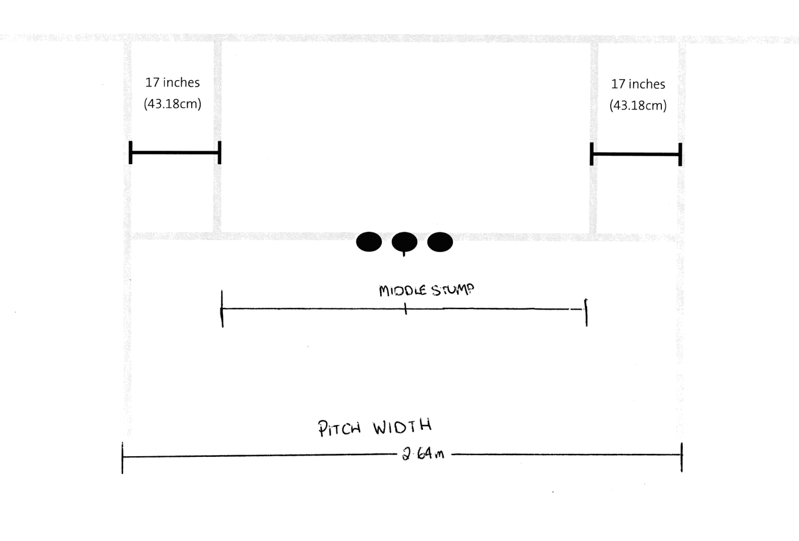
  - No Balls are scored as two additional runs to the batting team and not re-bowled unless it is the final over.
  - In the final over, No Balls only score 1 additional run to the batting the team.

