Where do I start?

- Plan what you are going to do with clear regular goals and a long term outcome

- Ensure that your committee is supporting you and that your girls section is represented.

- Who is going to lead the initiative? Make sure you have the right person – don’t just pick the first volunteer. It’s about a good positive experience.

- Is your club girl- ready? What messages are you sending to girls coming into your club?

- What will the costs be? Will they need kit?

- When are you going to train? Will it be at junior training with a dedicated coach or have a separate evening?

- Make sure everyone at your club has the message and is on board

- Take it one step at a time – don’t expect too much too soon.

- Contact Ann-Marie Presswell, the Women and Girls Development Officer to see what support and help is available.

How do I go about recruiting?

- Beyond All Stars: Can you use Dynamos Cricket as an offer for girls and run a sessions for girls only?
Make sure that the All Star girls are clear about what happens next.

- Recruit from within – run mums and girls day for families already associated with the club

- Advertise to local girls sport groups: netball, hockey, gym clubs, dance. Can you offer a taster session?

- Contact girl groups: Rainbows, Brownies and Guides and offer taster sessions/give out flyers. Find out your group here
https://www.girlguiding.org.uk/get-involved/find-your-nearest-unit/

- Contact your local primary school – can you run taster sessions for girls or hold a girls festival at your club?

Girls are unlikely to sign up on their own, so advertising and giving them taster sessions where they already are in an established group of friends is an ideal opportunity to attract a group that may come together.

Visit the ECB website to find out more about clubs that have set up a girl section:

https://www.ecb.co.uk/be-involved/club-support/programme-support/women-and-girls

What should the training look like?

- Like the training and coaching you already provide- well planned, skill-based, active, fun and productive

- Fun, child-centred

- Social: as well as training and developing skills, girls may also like to use the time socially. Plan for this in your session.

- Make sure that there is competition and valuable playing opportunities

- Ensure that there is opportunity to incorporate rules and officiating into the game, so they begin to have ownership of their cricket.

Here are some resources that you can use during training:

icoachcricket
https://icoachcricket.ecb.co.uk/

Chance to Shine
https://www.chancetoshine.org

Clubs with girls’ sections in Devon

Bovey Tracey Cricket Club
Chagford cricket Club
Clyst St George
Cornwood Cricket Club
Culmstock Cricket Club
Exeter Cricket Club
Exmouth Cricket Club:
Filleigh Cricket Club
Hatherleigh Cricket Club
Heathcoat Cricket Club
Holsworthy Cricket Club
Ipplepen Cricket Club
North Devon Cricket Club
Ottery St Mary Cricket Club
Paignton Cricket Club
Plymouth Cricket Club
Plympton Cricket Club
Sidbury Cricket Club
Sidmouth Cricket Club
South Devon Cricket Club
Teignmouth and Shaldon Cricket Club
Topsham St James Cricket Club
Whimple Cricket Club
Whitchurch Cricket Club

What opportunities are there for girls to play cricket in Devon?
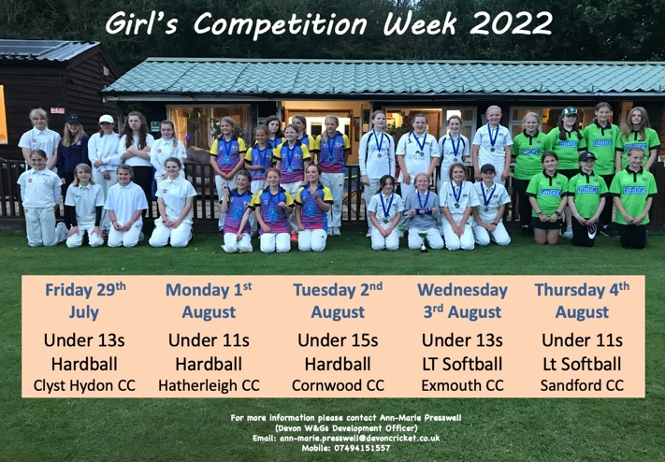

UNDER 11S FESTIVALS

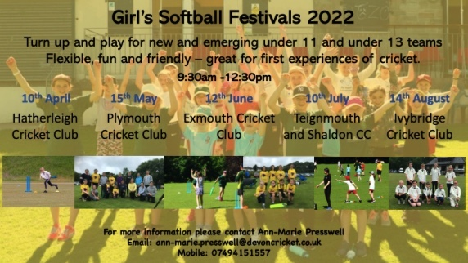
Contacts at Devon Cricket
Women and Girls Development Officer
Ann-Marie Presswell
07494151557
ann-marie.presswell@devoncricket.co.uk

All Stars and Dynamos Cricket
Alex Jopling
07507711595
alex.jopling@devoncricket.co.uk

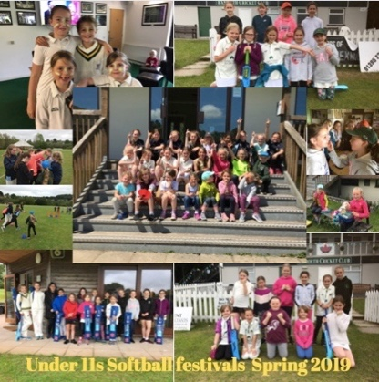

Developing a Girl’s Section at your club

