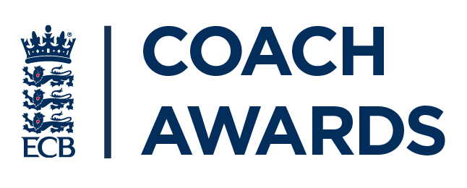

Nominator’s Details

Full name:

Email address:
Club/school/county:

Nominee’s Details

Full name:

Address:

Telephone number:

Email address:

Which category are you nominating them for?  Please highlight or circle | Young Coach of the Year  Coach of the Year  Outstanding Contribution – Services to Coaching  Outstanding Contribution – Services to Coach Development
Current position:

Coaching qualifications:

Years of service:

Professional status – paid or voluntary role:
Please outline below why you are nominating this person. Consider questions such as:
- How have they made a difference?
- How many people have they had an impact on?
- What have they achieved?

The information given in this form will be used by the Devon Cricket Board to consider the award of a Coach Award to the person you are nominating on this form. If your nomination is also selected as an overall National Winner, the ECB will then contact the winner to explain how their personal information will be used.

By ticking this box, I can confirm that I have read the ECB's Privacy Policy http://bit.ly/ECBPrivacyPolicy and understand how my personal data will be used.

By ticking this box, I can confirm that I have read the Devon Cricket Board Privacy Policy www.devoncricket.co.uk/county-policies and understand how my personal data will be used.

Please return the nominations form below to coaches@devoncricket.co.uk before Monday 27th September 2021 at 12pm.
Please submit separate forms for separate nominations.

